Playful Post - Red Activity Sheet 1:
Design Your Own Postage Stamps

Have a go at designing your own set of stamps. You might want to draw people, your favourite things, special events or maybe places.
You can even colour them in!

Turn over for instructions on silhouette (shadow) drawings.
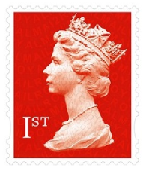
Extra activity: Silhouette (Shadow) Drawings

Normal stamps feature a side view of the Queen or a ‘profile’ drawing. You can create your own profile drawings of people or things using shadows.
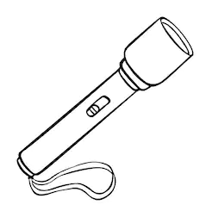
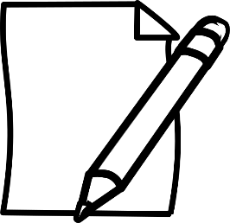
Resources
- Blank paper
- Torch or sunlight
- A pencil
- A person or a toy to be your model

Instructions
- Set up your artist studio outside - On a sunny day find a place outside and place a toy on a piece of plain white paper
- Draw around the shadow created by the toy using your pencil (hint: you might need to hold it with your other hand to get a good shadow)
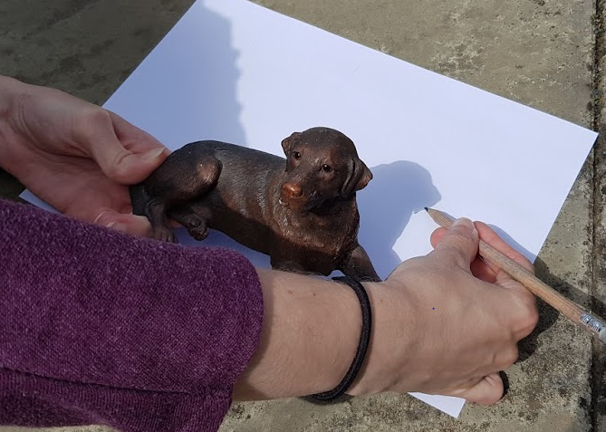
- If you want, you can colour it in or add things like eyes, nose, mouth
etc.

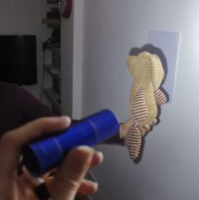
OR
- Set up your artist studio inside – Stick a piece of plain paper on the wall using easy to remove blue tac or sticky tape (ask permission first!)
- Ask your model to sit on a chair sideways in front of it or to hold up a toy there
- Using a torch try to get the person’s shadow on the paper and then draw around it
- If you want you can colour it in or add things like eyes, nose, mouth etc.

