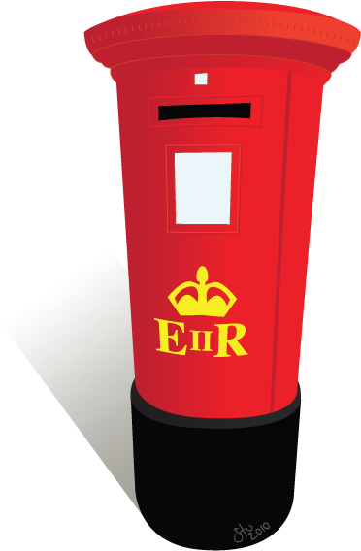
Carnegie Creators @ Home
Week 1: Playful Post

Victorian Invention: The Postal Service
Have you had any parcels or letters delivered to your house recently? Well they will probably have come by post! But when Andrew Carnegie was born, the postal service as we know it didn’t exist – if you wanted to send a letter you had to wait until a person came along your street to collect them.
During his lifetime there were lots of big changes to do with post….
Did you know…
post boxes used to be green!!

1840: The first adhesive (sticky) postage stamp to be used publicly,
the ‘Penny Black,’ was introduced
1843: The first Christmas card was sent
1852: Post boxes were introduced
1870: The first postcards were issued in the UK
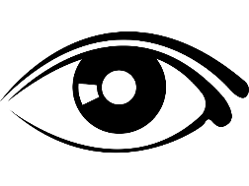
LOOK

Have a look at the pictures below, these are two mailboxes in Dunfermline – maybe you will see them when you are out for a walk!

Question: What letters can you see? Can you guess what they stand for?
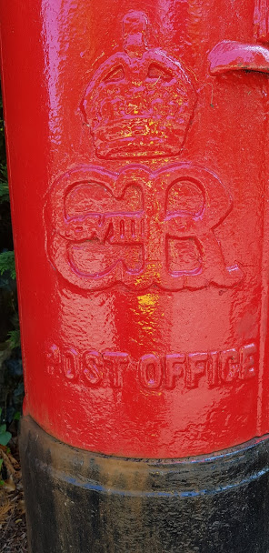
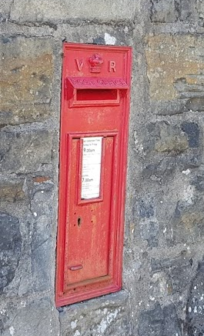

AND

THINK

Click for a video of Lynsey talking about Post box 1

Post box 2: On Comely Park
Post box 1: On Moodie Street, opposite the Andrew Carnegie Birthplace Museum

The letters on a post box tell us which King or Queen was on the throne when it was made. The first letter is for their name and the R stands for either ‘Regina’ or ‘Rex’ meaning Queen or King in Latin. The Vs and Is are Roman numerals.
So most of our post boxes today have ‘E II R’ for today’s Queen, ‘Queen Elizabeth the second’ but…
Please turn over

Postbox 1 has ‘VR’ for Queen Victoria, who became Queen over 180 years ago!
And Postbox 2 is even more special as it was made under King Edward VIII (the eighth) who was King for less than a year! There were only 161 of these ever made.
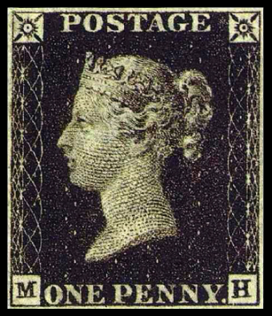
The Penny Black Postage Stamp
This was the first adhesive (sticky) stamp used for UK post 180 years ago!

Questions:
- Why do you think it was called the ‘penny black’ stamp?
Clue: Think about the colour and the price!

- Who do you think the picture is of?
Clue: What is she wearing on her head?

Andrew Carnegie was once featured on his very own stamp!
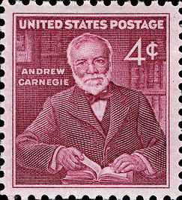
He’s also on lots of postcards in our shop!
Carnegie Connections
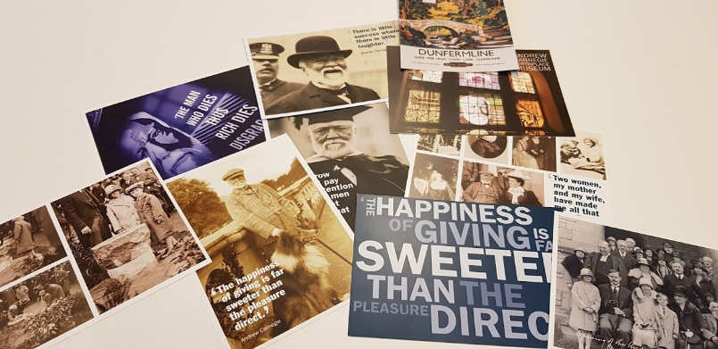

DO

Some ideas for playful post activities….
Make and send a postcard
Use Red Activity Sheet 2 to design a postcard of your special place and write a message on the back.
Why not send your postcard to someone special or send it to us so we can see your amazing design?
Andrew Carnegie Birthplace Museum, Moodie Street, Dunfermline, KY12 7PL

Design your own postage stamps
Use Red Activity Sheet 1 to draw your own stamp designs.
You could draw people or places or something completely different!
Stamps often feature silhouettes (outlines) of people, you can create your own silhouettes using torches or sunlight.
Play Postal Worker
Write or draw a letter for everyone in your house and deliver them, don’t forget to sort them into A-Z order first!
You can even make your own post box for your house using an old cereal box and post each other letters.
And a little song about postal workers (to the tune of ‘I’m A Little Tea Pot’)
I deliver mail, rain or shine
If you put a stamp on, it will get there in time
Can you help me sort my mail today?
Collect the ones that start with ….. (pick a letter and find things in the room that start with it)

