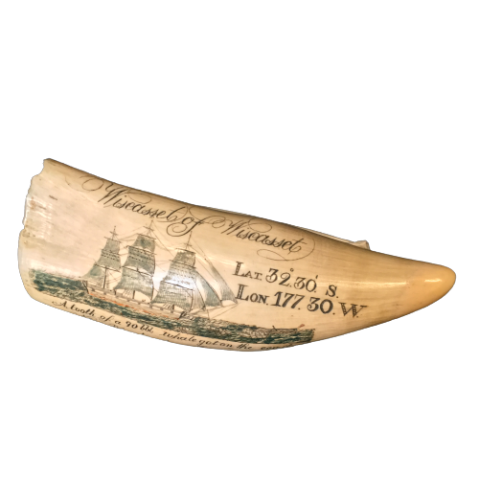

At the Andrew Carnegie Birthplace we have lots of interesting and unusual objects such as this scrimshaw. A scrimshaw is a decorative engraving in bone, in this case, a ship carved onto a whale’s tooth.

The Carnegies have a problem – they have forgotten the name of the ship they’re catching from Scotland to America! Can you work out the name of the ship by solving the crossword clues and unscrambling the letters marked with a yellow dot to spell out the ship’s name.
The ship is a past-portal and will allow you to travel back in time.
Tip: All the crossword clues are related to Carnegie story or Victorian Life.
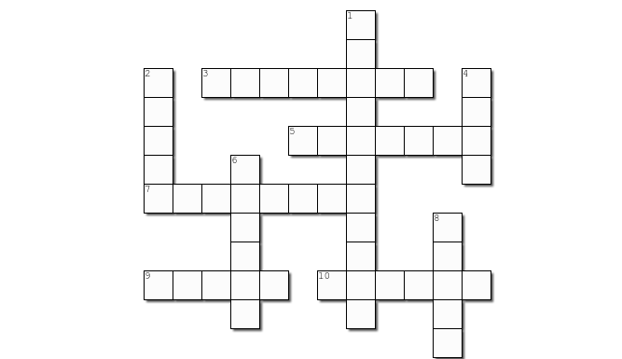

DOWN
- A bowl that is an indoor toilet. Kept under the bed!

- The material William Carnegie would weave. Clue: not cotton! Light and airy, made from flax.

- The only original piece of furniture left at the museum. Clue: William Carnegie may have written letters at it.
6. William Carnegie’s job. Rhymes with beaver.
8. A feather pen you dip into ink.
Arrange these letters backwards for the answer!
D R A U Q A J
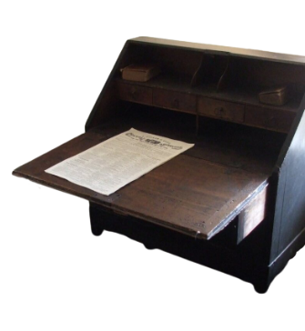
ACROSS
- The type of loom we have in the museum.
5. Andrew kept these animals as pets. They like carrots & lettuce!
7. The month Andrew Carnegie was born in. The 11th of the year.
9. Margaret Carnegie fixed these when the family were running out of money.
Clue: You wear them on your feet!
10. You use this cone when weaving, it has thread wrapped around it.
Clue: There is a popular nursery rhyme called ‘Wind the ___ up’

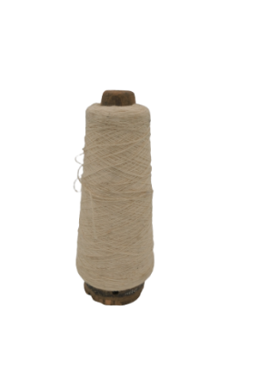

No. 4 Down
No. 3 Across

Once you’ve solved all the clues, write down the letters in the boxes with a yellow dot. Unscramble the letters & make a note of the word below.
_ _ _ _ _ _ _ _ _

Need a clue? Have a closer look at the scrimshaw picture.
Can you see any letters which spell out a name?

Still stuck? The answer is hidden at the bottom of this page.

Once you’ve solved it & found the past-portal, click here to return to the HQ Explorer Time-Quest webpage to try another puzzle and complete the Time-Quest challenge.

