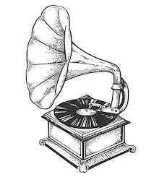
Carnegie Creators @ Home
Week 2: Groovy Gramophones

Victorian Invention: The Gramophone
Do you love listening to music? Well, it was during the Victorian times that people were able to buy the first music players for their home – the ‘Phonograph’ or ‘Gramophone’. They would have to buy records of their favourite singers or bands. A little different from today where most people listen to music online on their mobile phones!
LOOK

This is a picture of the gramophone we have at the museum – it plays a recording of Andrew Carnegie or a selection of songs.
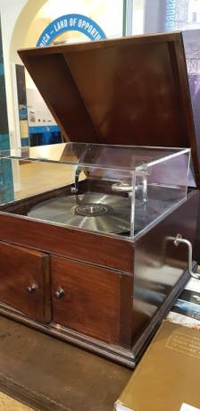
Click to watch a video of the Gramophone

Questions – Can you spot….
- The record? This is the large circular disc where the sound is stored. People would have different records or albums from different singers/bands.
- The needle? This is the pointy piece of metal that goes into the grooves on the records and reads the sound

Andrew Carnegie loved music ever since he was little. So much so that he paid for an amazing music hall in New York, called the Carnegie Hall! Lots of famous people have performed there including the Beatles and the Rolling Stones!
Carnegie Connections
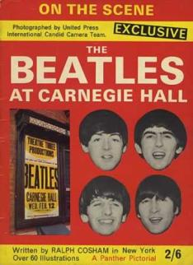
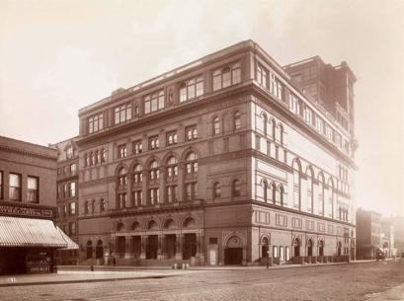

Did you know…
Dunfermline has its own Carnegie Hall built almost 50 years later.

THINK
The Greatest Hits Of…..
Make a list of your 10 favourite songs (either on paper or by making a digital playlist) or put together a concert programme of all your favourite singers/bands!
Ask your family to do the same – do you like the same songs or different ones?

Some ideas for Groovy Gramophone activities….
DO
Play Performance
Imagine you are in Carnegie Hall in New York and put on your own concert.
You can sing, dance and use your newly made music instruments.
Do you have anything at home you can use as a stage?
Make a musical instrument
It is possible to make music from anything! Pots and pans make great drums, rice in a jar can become a maraca shaker.
Get creative and see what instruments you can make from things you can find in your house or outside.

Design a cover for your imaginary album
Design an album cover for your favourite songs on blank paper!
What is the album called? ‘Now that’s What I Call Music’, ‘The Greatest Hits’ or something else?
Make it colourful and exciting!
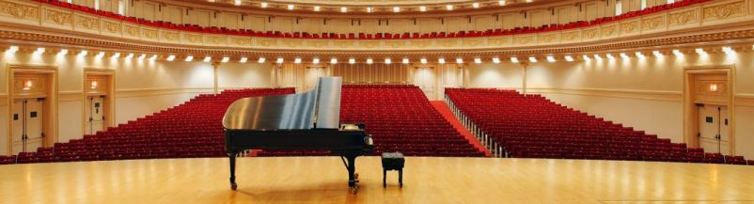
Imagine performing on this stage!

And a little song about music! Don’t forget to do the instrument actions!

Chorus
I am the music man
I come from down your way
And I can play… What can you play?
I play….
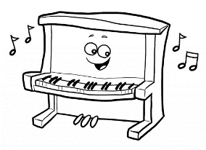
….The piano
Pia-pia-pia-no
Pia-no pia-no
Pia-pia-pia-no
Pia-pia-no

Chorus
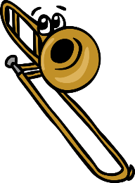
….the trombone
Umpa-umpa-um-pa-pa
Um-pa-pa um-pa-pa
Umpa-umpa-um-pa-pa
Umpa-um-pa-pa
You can listen to a different version of this song and sing along at https://www.youtube.com/watch?v=X_hftOu1lG0

[Followed by Piano! Pia-pia-pia-no]

Chorus
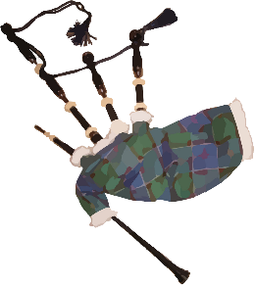
….I play the bagpipes
Pretend to play the bagpipes

[Followed by Trombone! Umpa-Umpa-Um-pa-pa & Piano! Pia-pia-pia-no]

Question: Can you think of any
other instruments to add? Maybe the tambourine or the saxophone

