Carnegie Creators @ Home
Week 4: Excellent X-Rays
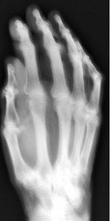
Victorian Invention: X-Rays
Have you ever had to have an X-Ray at the hospital? Do you know what an X-Ray is for?

X-ray machines allow doctors and scientists to look inside our bodies at the bones that make up our skeleton.

X-rays were discovered by accident in 1895 by Wilhelm Conrad Röntgen when Queen Victoria was on the throne – they were much blurrier and less safe then than they are today.

Did you know…
Most babies are born with 270 bones but when you are grown up you only have 207 as some join together!
Andrew Carnegie’s wife, Louise, paid for the
very first X-Ray machine in Dunfermline at
Carnegie Connections
Dunfermline College Hospital!
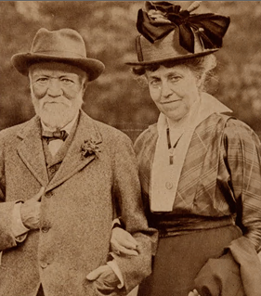
Here is a picture of her and Andrew….
LOOK

X-Ray Quiz

Question: Can you work out what part of the body these x-rays are of?
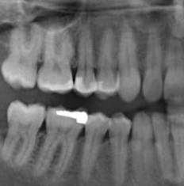
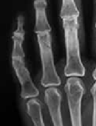
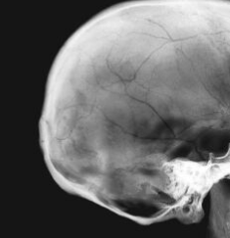
AND
3.
2.
1.

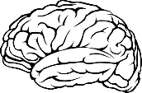
THINK

Please turn over
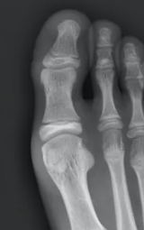
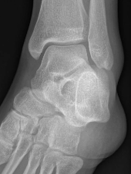
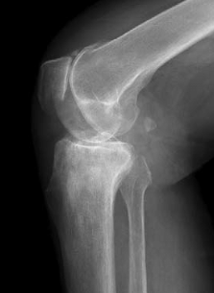
X-Ray Quiz answers:
- Skull (head) 2. Hand 3. Mouth 4. Knee 5. Foot 6. Ankle
6.
5.
4.

Some ideas for Excellent X-Ray activities….
DO
Use science to make some skeleton leaves
This is a really easy experiment! All you need to do is collect some leaves and put them in a tub (with a lid) and cover them with water.
As time passes you should see the green colour disappear and the leaves turn into skeleton leaves!
Hint: You might need to gently rub the leaves occasionally but be careful they don’t rip.
And a song you probably know to help you learn all about your own body/skeleton:
Head, Shoulders, Knees and Toes
Head, Shoulders, Knees and Toes, Knees and toes
And eyes and ears and mouth and nose
Head, shoulders, knees and toes

Question: Do you know the names of any other bones in your body? Maybe you can find them out!
Make a moving skeleton
Use Purple Activity Sheet 2 and see if you can put together a human skeleton.
If you have split pins, you can use these and your skeleton should move!

Make an X-Ray Tablet
Use Purple Activity Sheet 1 and follow the instructions to build your own x-ray tablet
Watch as the x-rays magically appear….

If you have access to the internet you can listen to the song Dem Bones and sing along – don’t forget to join in the actions:
https://www.youtube.com/watch?v=Jpvuqj5nv6U

