Carnegie Creators @ Home
Week 3: Comic Creations

Victorian Invention: Cartoons and comics
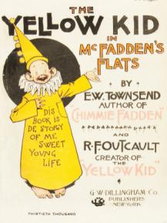
During the time Queen Victoria was on the throne, cartoons became more and more popular. They didn’t look like cartoons we see today though; they were black and white line drawings with lots of details and were thought to be funny at the time.

These soon changed and grew into comic books with The Yellow Kid in McFadden’s Flats published in 1897 the first book to call itself a ‘comic book’ – it looks very different from comics today!

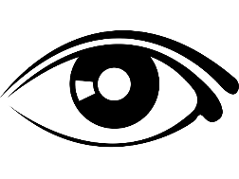
LOOK
As a famous and popular person Andrew Carnegie often had cartoons drawn of him, some of them were nice and some of them were not so nice….

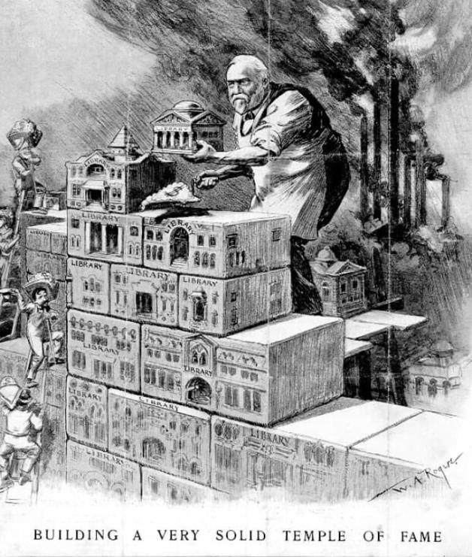

Carnegie Connections

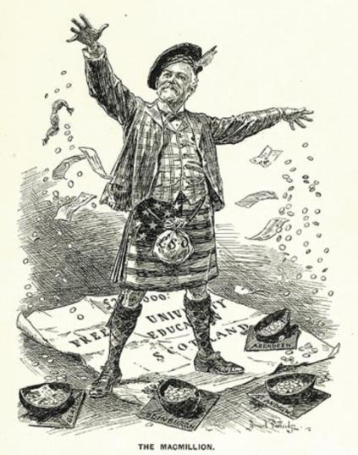
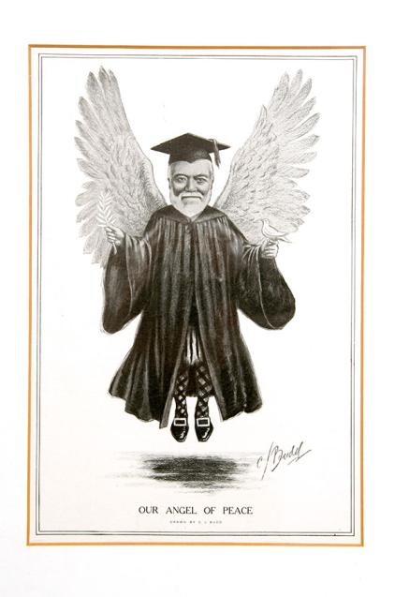
THINK
Andrew Carnegie was a very rich man but he gave almost all his money away to good causes. These cartoons provide lots of clues about the kind of things he funded. Can you become a cartoon detective and work out the answers to these questions…
Questions:
- Can you name three causes Andrew Carnegie supported?
Clue: Look at the words in the cartoons and what he is building
- Can you spot any clues that Andrew Carnegie was born in Scotland?
Clue: What is he wearing?
- Do you think the people drawing the cartoons liked him?
DO

Some ideas for Comic Creation activities….
Make a comic collage board
Do you have any comic books or magazines at home?
You can use these to make your very own comic collage board by cutting and sticking your favourite things onto a blank sheet of paper.
You can add your own drawings and words as well!

Create the Comic Book of You
Use green activity sheet 1 to design your very own comic book or cartoon about your life.
It could be about your favourite hobby, a special memory, you as a superhero or even just what you did yesterday!
Maybe it will just have pictures or it might have some words too.
Try and make it exciting and colourful!

Do some comic colouring
Green activity sheet 2 has some comic and cartoon drawings related to Carnegie for you to colour in.

