**Comic Creations Activity Sheet 1:**

**Do some comic colouring**



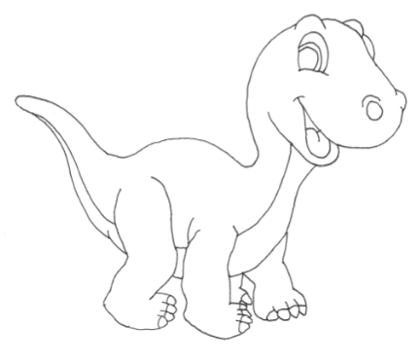

Did you know Andrew Carnegie has a dinosaur named after him – *Diplodocus Carnegii?*

Did you know Andrew Carnegie had pet bunnies when he was little?