How to get here
The Andrew Carnegie Birthplace Museum is easy to find whether you are using public transport or your own vehicle to get here. The following guide provides more information to help you plan your journey.
If you require any more information about travelling to the museum that is not included, please contact info@carnegiebirthplace.com or feel free to call us on 01383 724302.
__________________________________________________________________________________________

Contents
Pedestrians 2
Travel by Car 5
Travel by Train 8
Taxi Companies 13
Travel by Intercity Bus or Coach 14
Group Travel by Private Coach 18

Pedestrians

The museum is located within Dunfermline’s Heritage Quarter and is a short distance away from other central tourist attractions, including:
  - Dunfermline Abbey – 300 metres (0.2 miles) uphill via St Margaret Street. Total ascent/descent of route is 72ft
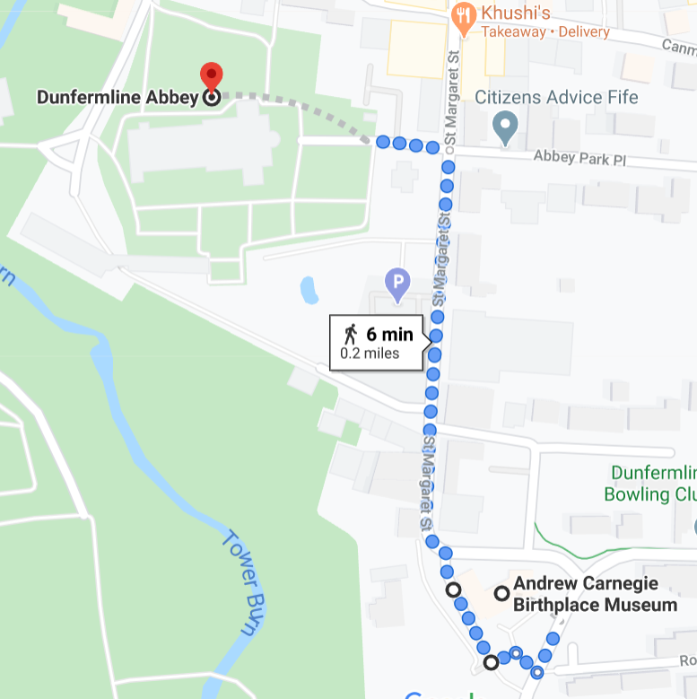

  - Dunfermline Palace Kiosk (Historic Environment Scotland) – 260 metres (0.16 miles) via Monastery St. Total ascent/descent 26ft.
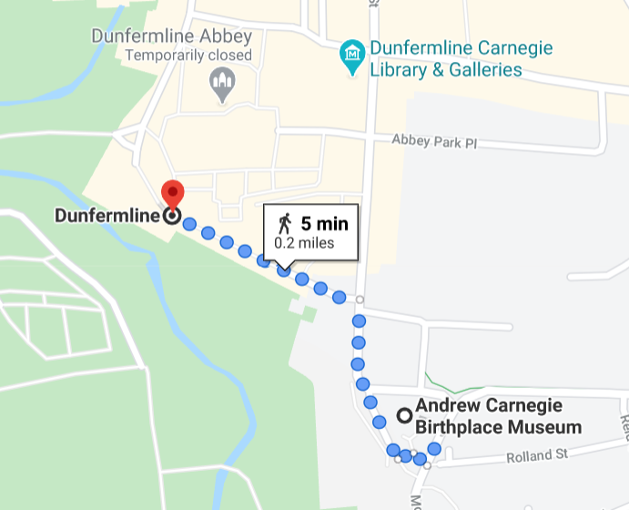

  - Abbot House and Dunfermline Carnegie Library & Galleries – 360 metres (0.25 miles) uphill via St Margaret’s St and Abbot St. Total uphill ascent/descent of route is 82ft.
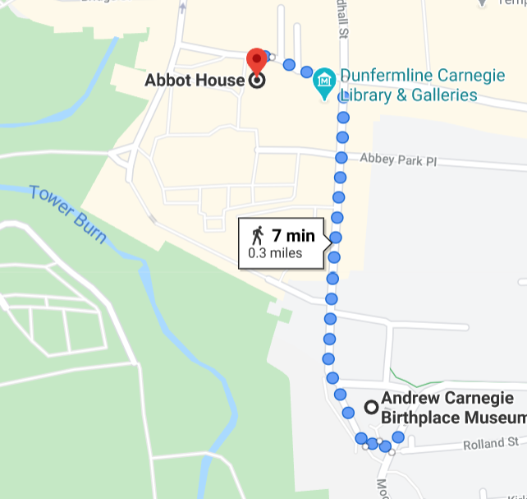

  - Pittencrieﬀ Park – Closest level access entrance is 320 metres (0.2 miles) from the museum and the route is in a pedestrian zone via Monastery St. Total ascent/descent of route is 32ft.

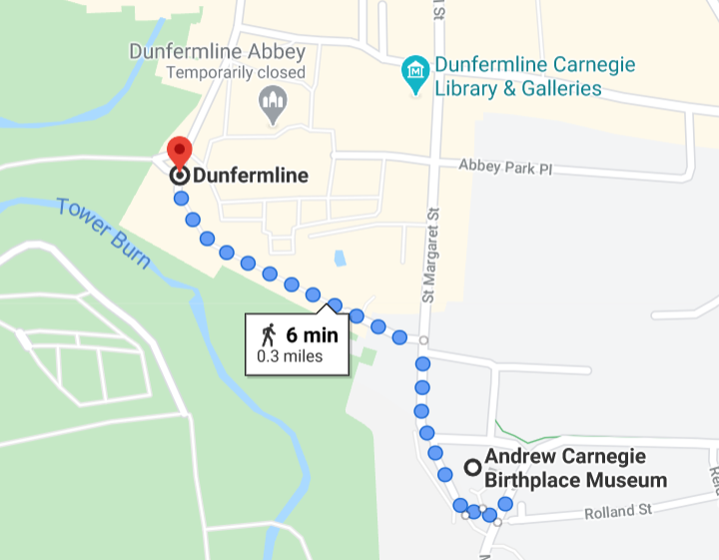

Accessing all these routes requires travelling via St Margaret’s Street. Please be aware the bottom of these street (end closest to Museum) the paths on both side are narrow, measuring approximately 80cm wide. This stretch of narrow path is only 50 metres in length, after which the path gets wider.
The pedestrian zone between Monastery Street and Pittencrieff Park is evenly paved. From round Abbot St leading to Maygate and St Catherine’s Wynd next to the Abbey, the road is cobbled but paths remain relatively even and paved. It is a one-way system for drivers.
Please note there are currently long-term roadworks in this area.

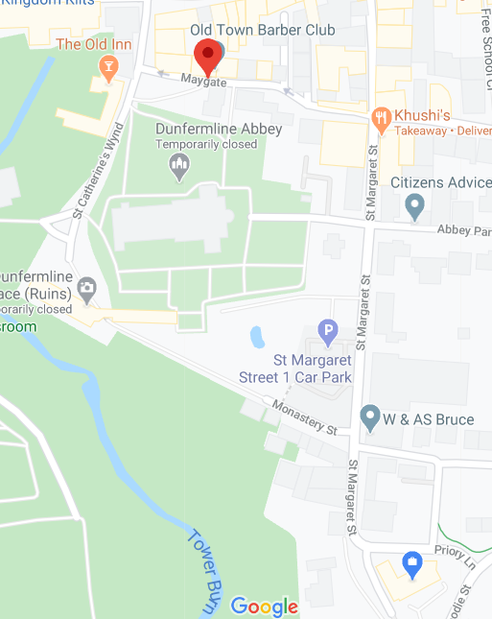
Museum

Abbot Street

Travel by Car

Dunfermline is conveniently located off the M90 motorway and is accessible via the main roads through Fife such as the A92.
There are multiple pay and display car parks conveniently located around Dunfermline Town Centre. Some are long stay and some short stay, so depending on the length of your visit and what else you are planning to visit, you may wish to park further away from the museum.
The largest long stay Pay & Display car park in town is the Glen Bridge Car Park, Chalmers St, Dunfermline KY12 8DF. St Margaret’s Cave is located in the corner of this car park and is free to visit. This car park is marked on the map below with ‘P’ in blue square.
All pay and display car parks in the Heritage Quarter are indicated on the map below.

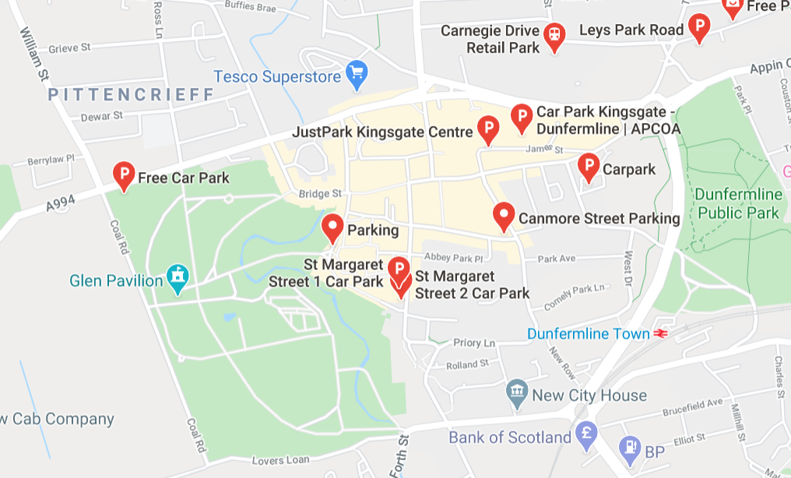
Museum located between Moodie Street and Priory Lane.

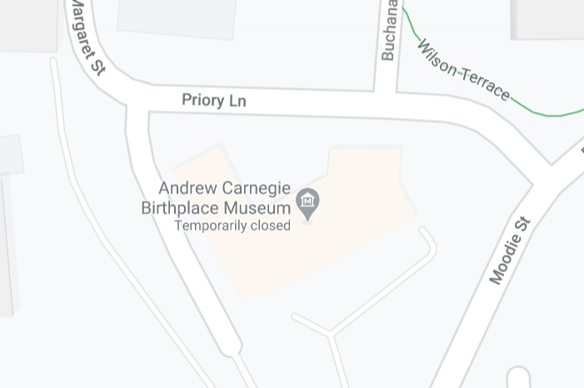
The closest car park to the museum is located directly outside and is a long stay car park. Entrance to the car park is on Priory Lane (photo below)

- If using a Sat Nav to find the museum, use the postcode KY12 7PL
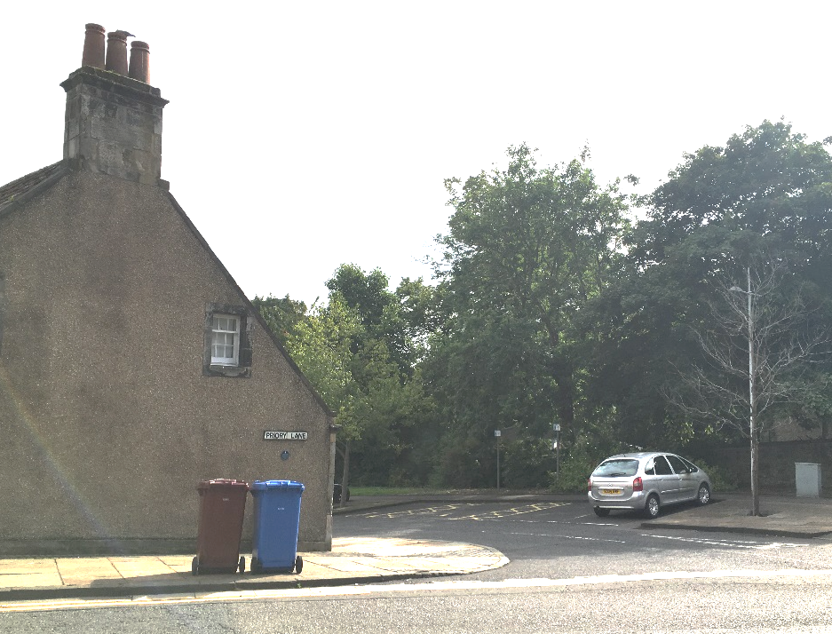
- There are 38 parking spaces, including two designated Blue Badge holders’ bays. The two accessible bays are located directly opposite the Birthplace Cottage side entrance, approximately 10 metres away. This door is the only level access entrance point to the museum.
  - The surface from the car park to the entrance of the museum is paved and there is a slight incline.
  - You can pay for your parking session using a contactless method too. If you have a smartphone and are able to download apps, we recommend downloading the RingGo app before your visit. You can use the app to pay for parking in all Fife Council car parks. There is a small charge for using the app.
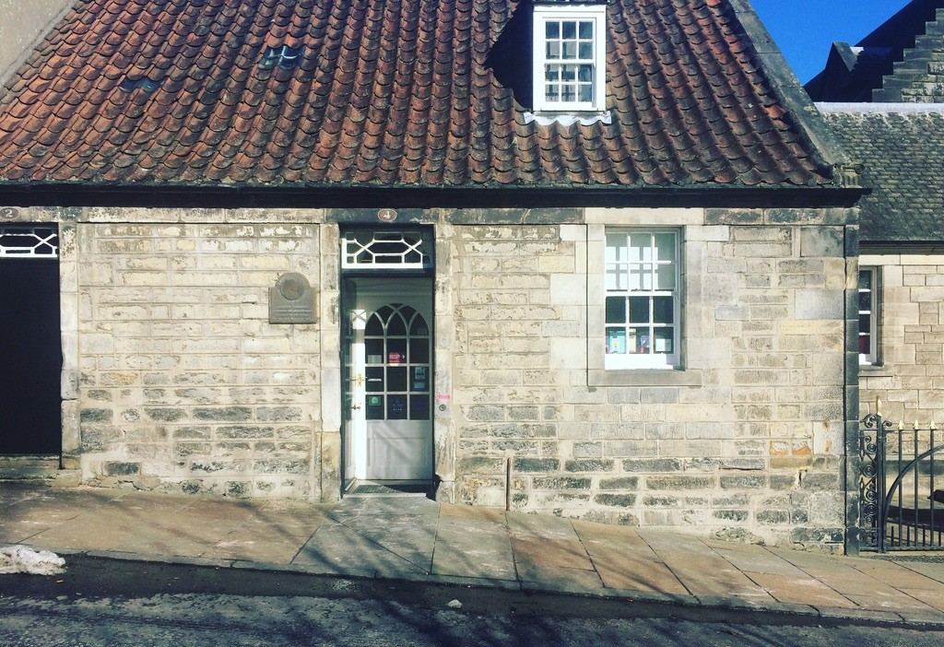
Side entrance with level access. This door is locked for security reasons.

Please ring doorbell (right hand side) on arrival and a staff member will let you in.

Travel by Train

The nearest train station to the museum is Dunfermline Town station, approximately ½ a mile or 800 metres from the museum.
There are three pedestrian routes from the station to the museum.

Route A via Comely Park and Priory Lane
Level access is limited on this route because there are steps between the station and Comely Park. There are 21 steep steps in total.
After the steps at the start of the route, the paved route is generally even.
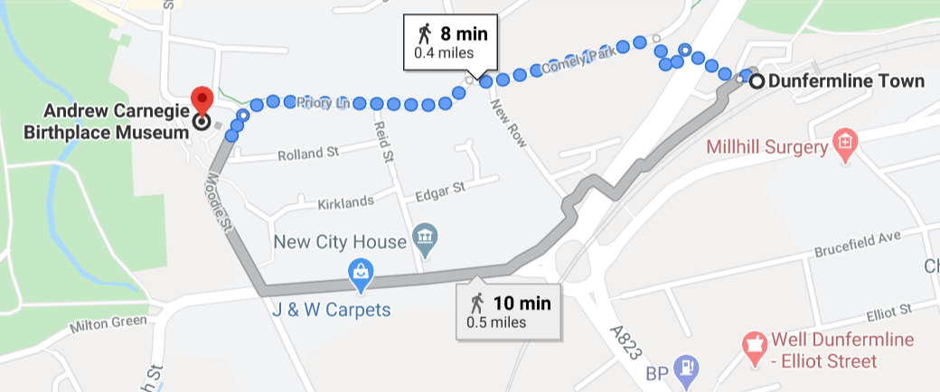
Total ascent of route is 46ft.

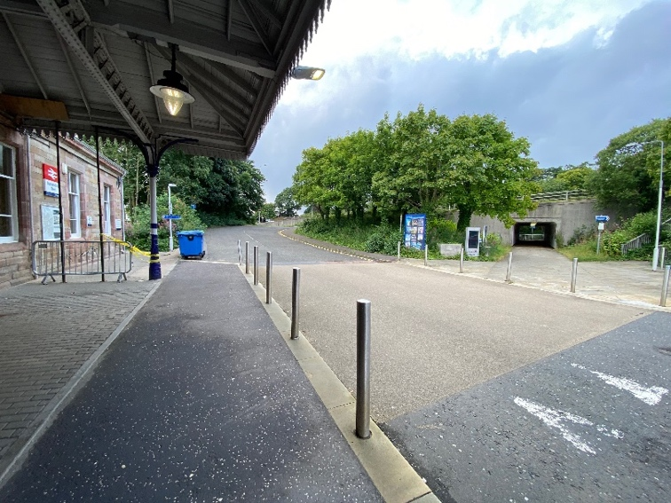
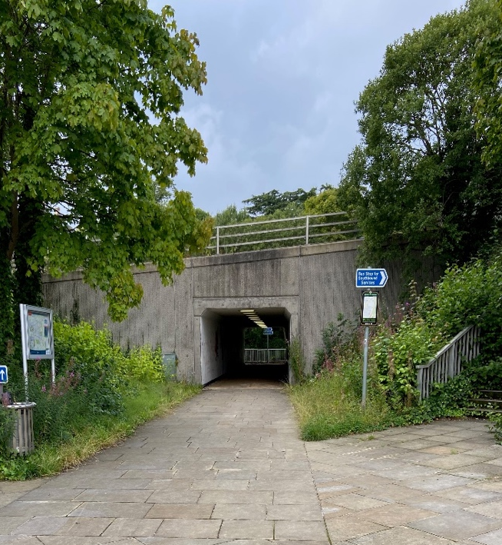
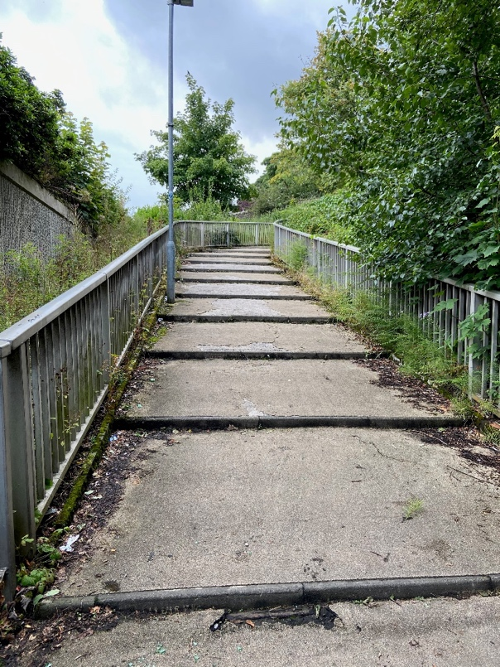

Route A in pictures. Top row left to right: Dunfermline station; pedestrian tunnel.
Bottom row left to right: Under the tunnel, turn left at the end; steps leading up to Comely Park.

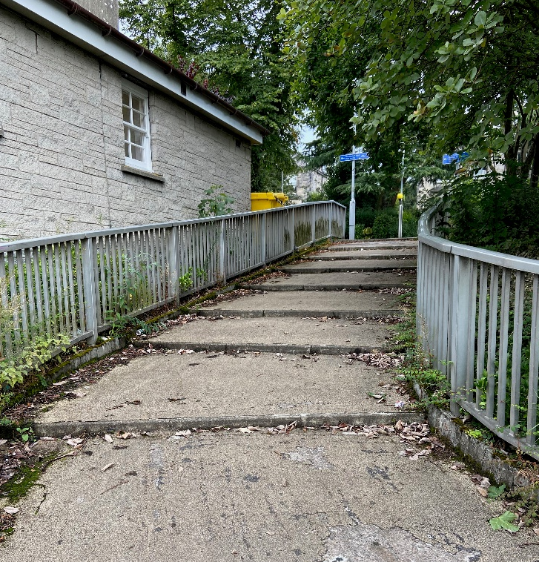
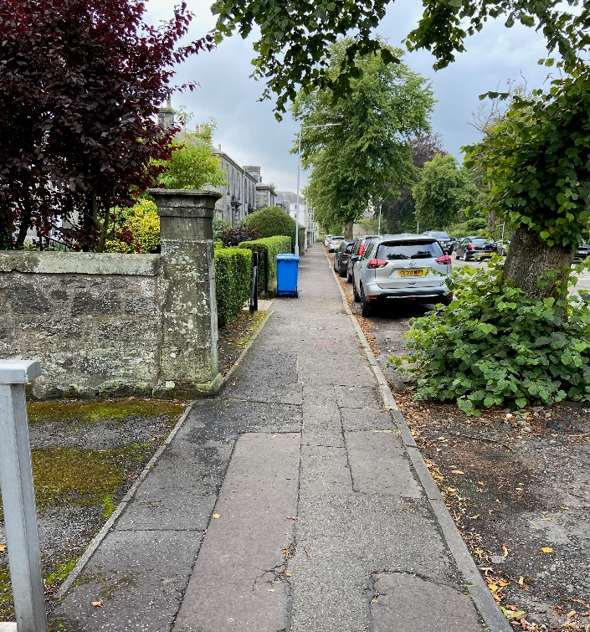
Images continued: left to right, steps continuing up to Comely Park; View of Comely Park in direction of Priory Lane.

Accessible Route B via Comely Park
This route is very similar to Route A in that it goes via Comely Park and Priory Lane along to the museum. However, this route uses the ramp system and other paths with level access to Comely Park. You start your route on the same side of the station as Route A, but you do not travel through the tunnel and via the steps.

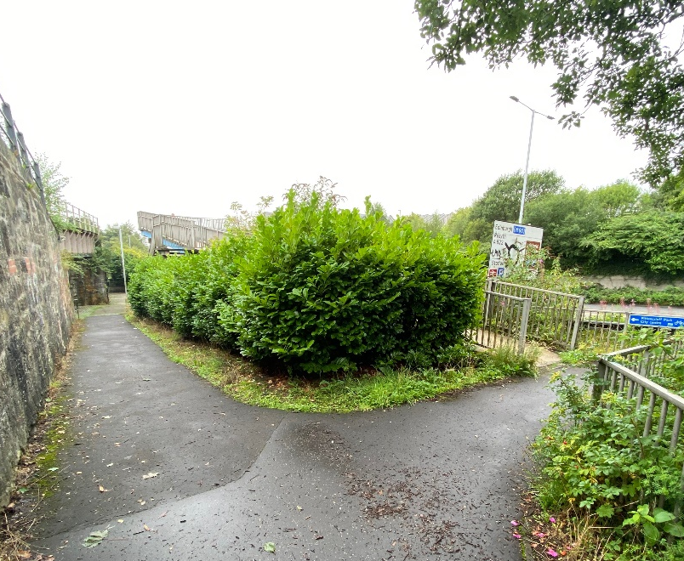
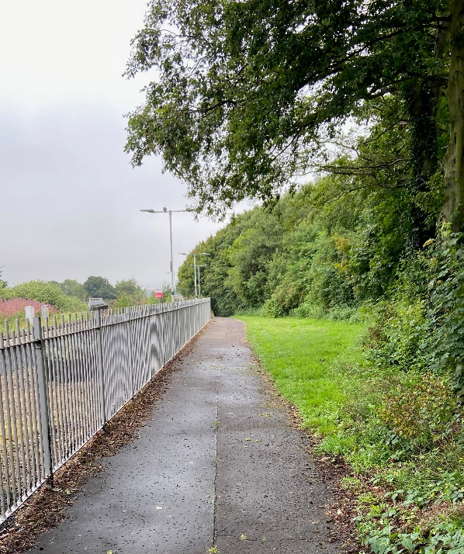

Top row left to right: Dunfermline station, sign at far end directing pedestrians to town centre.
Bottom row: photographs of the level path leading to centre.

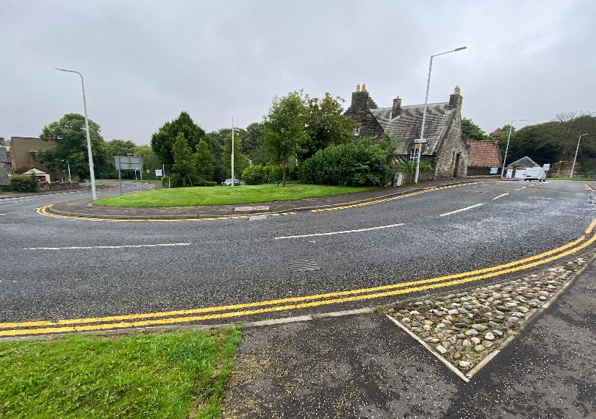
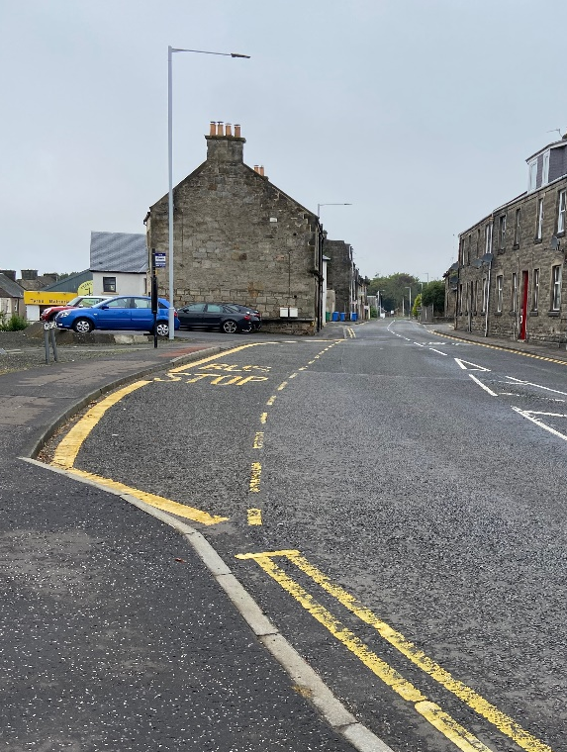

Top row left to right: view of bridge from train station; view along Comely Street.
Bottom row left to right: view along Priory Lane; museum on corner of Moodie St and Priory Lane.

Route C via Woodmill St and Nethertown Broad St
There are no steps along this route and the paths are paved. There are four pedestrian crossings with traﬃc lights along the route. You start on the other side of the station.
The steepest part of this route is between Nethertown Broad St and up along Moodie St. Total ascent of route is 66ft.
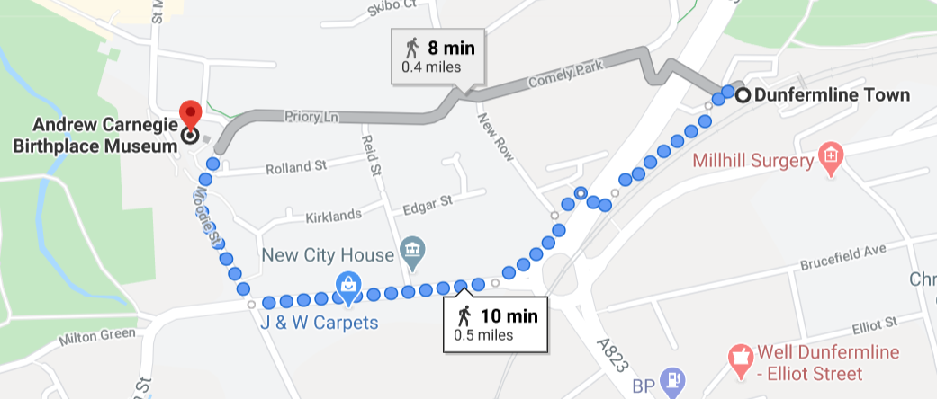
For accessing updated travel information and if you have access to a smartphone device, download the free ScotRail App. We also provide complimentary Wi-Fi access at the museum so you can check your return journey times too. We have a selection of paper copies of timetables available for visitors to take too.
__________________________________________________________________________________________

Taxi Companies
There is a taxi rank in front of the station, however we recommend booking a taxi in advance. Here are some local companies we recommend:
- Dunfermline Taxis 01383 733733
- Abbey Taxis 01383 735555
- Corporate Dunfermline Taxis 01383 252525

If you require level access, please ask your driver to drop you off at the side entrance of the museum, opposite the pay and display unit. Ring the grey doorbell to the right hand side of the door. (See page 7 for picture)
__________________________________________________________________________________________

Travel by Intercity Bus or Coach
- The most direct route to the museum from the bus station is walking down Cross Wynd, Guildhall Street and downhill via St Margaret Street. Cross Wynd and Guildhall Street are cobbled surfaces, whilst there is even pavement down both side of St Margaret’s St.
- The distance is 640 metres (0.4 miles) and journey ascent/descent is 118 feet.
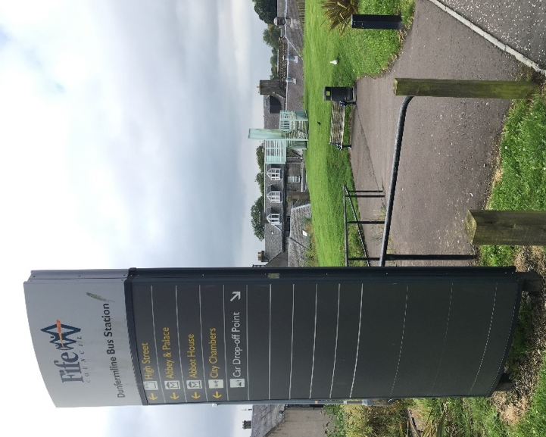
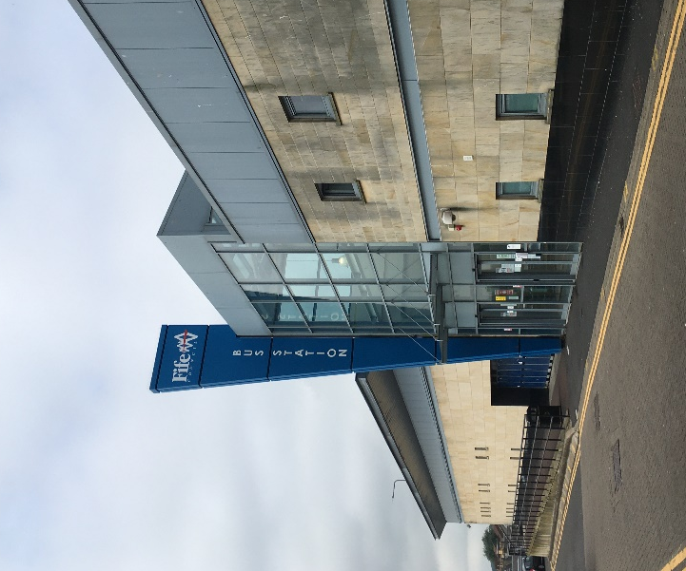
- The route to the museum with the smallest incline is travelling down the sloped ramp from the station to along the High Street. Turn left to Kirkgate and then walking along St Catherine’s Wynd and Monastery Street, and finally St Margaret’s Street. The High Street, Kirkgate and St Catherine’s Wynd are cobbled surfaces, whilst the pavement is even along Monastery Street. The High Street and Monastery Street are pedestrian zones.
We have provided pictures of the most accessible route. Images show Dunfermline Bus Station (left) and the sloped path leading to the High Street (right).

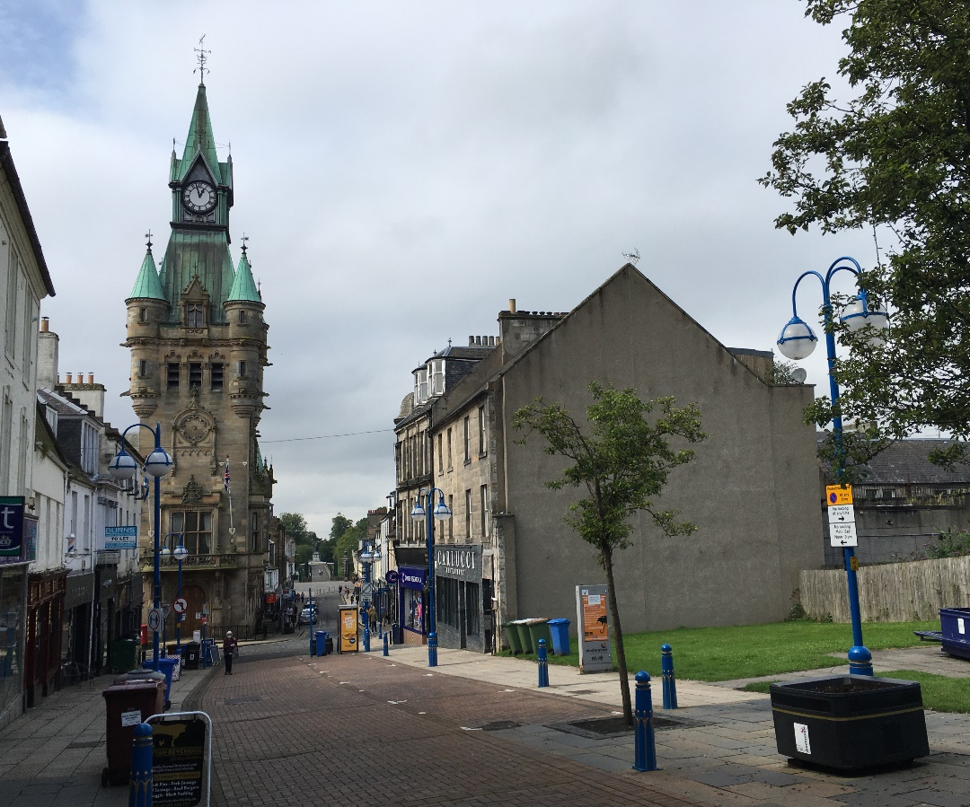
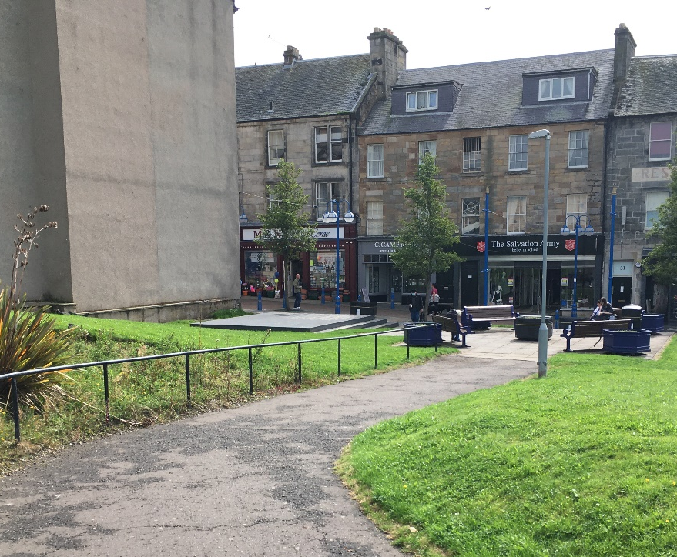
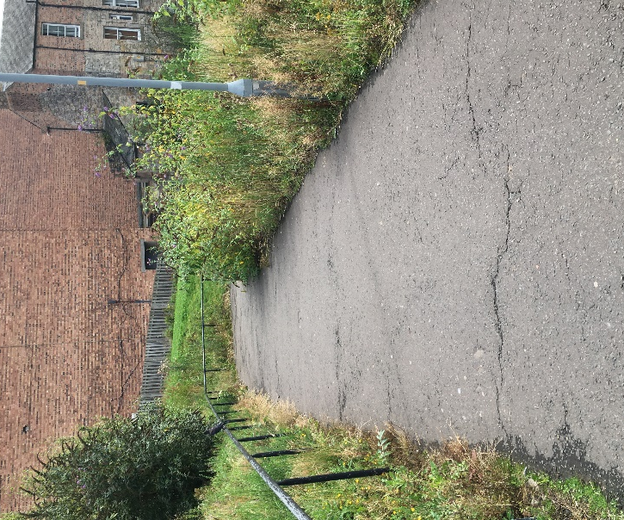

Photos top to bottom:
Two photos of the sloped path leading down from bus station to High Street.
View of the cobbled path area leading down to the High Street. To the left of Dunfermline’s City Chambers is Kirkgate. There is a dropped path enabling wheelchair and buggy users to cross the street.
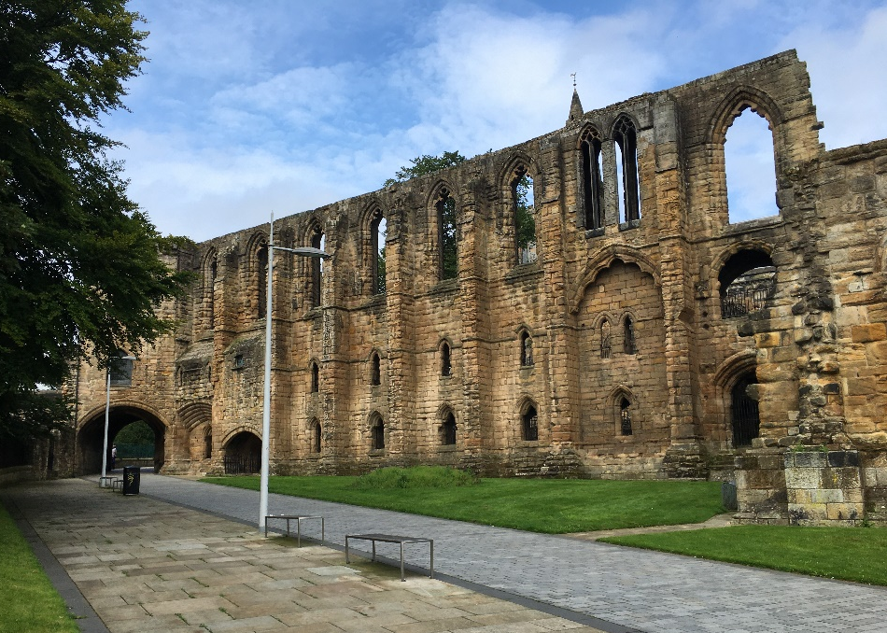
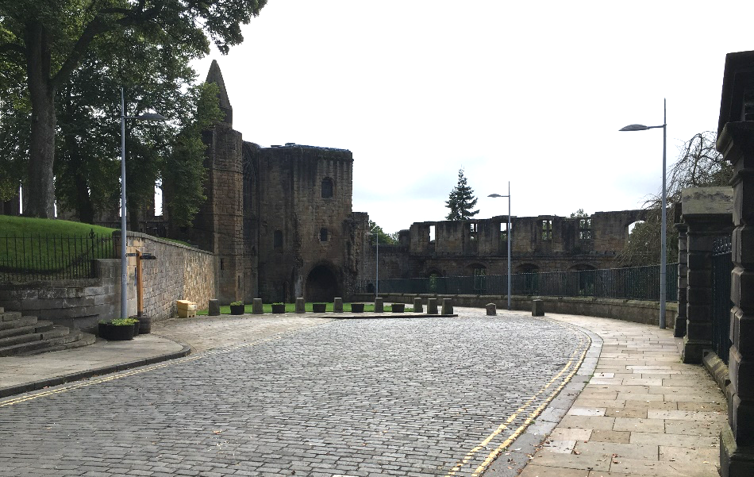

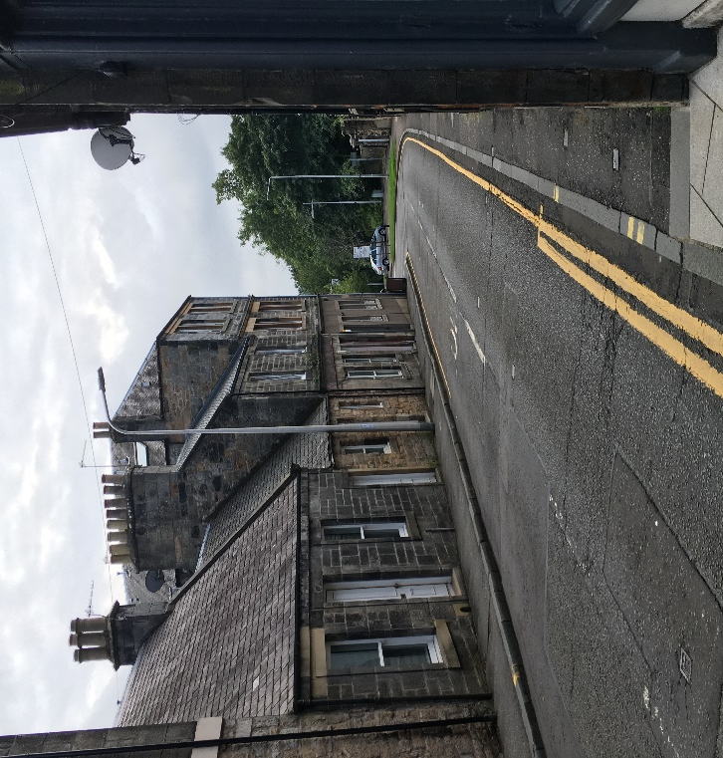
Photos top to bottom:
St Catherine’s Wynd adjacent to Abbey.
Pedestrian area of Monastery Street.
View of St Margaret’s Street (Birthplace car park is visible at the bottom.)
- The total distance is approximately 840 metres (0.5 miles) and total ascent/descent is 114 feet.

- There is a taxi rank outside the bus station on Queen Anne Street should you need it to get to the museum. We recommend booking a taxi in advance, please see the list on page 13.

For accessing updated travel information and if you have access to a smartphone device, download the free Traveline or Stagecoach App. We also provide complimentary Wi-Fi access at the museum so you can check your return journey times too. We have a selection of paper copies of bus timetables available for visitors to take too.

There are a number of bus stops near the museum serving local town routes too.
On Moodie Street, there is a stop for buses 3, 3A and 5.
Click here to see a map of those routes.
__________________________________________________________________________________________

Group Travel by Private Coach

There are no coach parking bays in the car park just outside the museum. There is however a convenient drop off point for coaches on Moodie St. It is marked below.

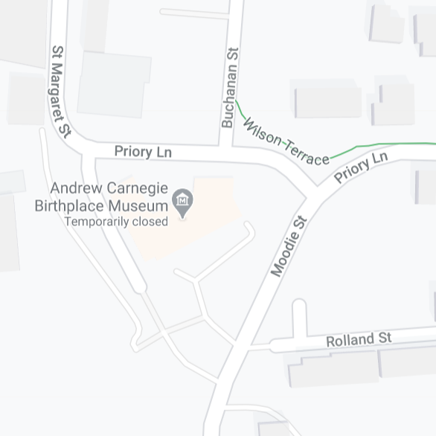
Coach drop off bay located on left hand lane, Moodie Street.

There is limited coach parking available in the Glen Bridge Car Park, marked on the map above. Approximately 1.5 miles away from the museum.
This car park is pay and display.
Many coaches arriving in Dunfermline park temporarily on St Margaret St, but please note this street is steep and can get narrow. The roads around the Heritage Quarter and leading to the end of the High St / Bruce St are one way and narrow, making it difficult for coaches to turn.
Coaches should not use the narrow Coal Road to travel to the top end of Pittencrieff Park and to access its car park. Instead use the longer route via Carnegie Drive.
Please consider these factors when planning your route via coach.

